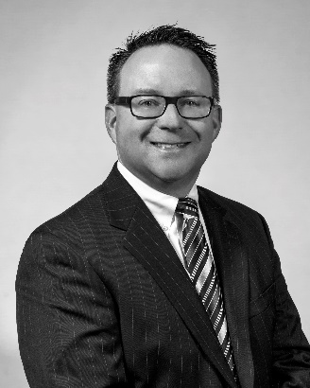

Name: Stephen Weber

Mr. Weber joined O’Keefe in August of 2007. He works with clients in the fields of turnaround management and business refinancing, litigation support, forensic and fraud evaluations, as well as performance improvement. Prior to this, he was a Manager with Adamy + Company, P.C. (now Baker Holtz). During his time with Adamy, focus was on accounting compliance services for closely-held businesses primarily in the manufacturing arena, but he also worked in Litigation Support and Business Valuation.

Prior to joining Adamy + Company, Mr. Weber worked with two companies in Ohio. As a manager at Convergys Corporation, he was the Corporate Financial Manager for nine divisions representing $325 million in annual revenue. There, he developed strategies to reduce costs and facilitate reporting across divisions utilizing operational metrics and value drivers. He also worked at a large, local accounting firm in Cincinnati where he conducted audits of manufacturing companies, restaurant holding companies, real estate holding companies, and employee benefit plans.

Mr. Weber earned his Bachelor of Science degree in Accounting and Finance from Miami University in Oxford, Ohio. He is a Certified Public Accountant (CPA) and is Certified in Financial Forensics (CFF). He is a Certified Turnaround Analyst (CTA) through the Turnaround Management Association. He is a member of: the American Institute of Certified Public Accountants (AICPA) and the Michigan Association of Certified Public Accountants (MACPA). He is an active member of the Turnaround Management Association (TMA) and is currently a Board Member and Past President for the West Michigan Chapter. Mr. Weber is a Board Member for the Risk Management Association (RMA) in Michigan and serves as the Past President for the Western Michigan subchapter of RMA. He is also co-chairing a new event: RMA West Michigan Commercial Credit Analysis Competition bringing together teams of undergraduate students from GVSU, WMU, Hope College, and Davenport University for a loan analysis competition. He also serves on the new business development council for the Heart of West Michigan United Way.

