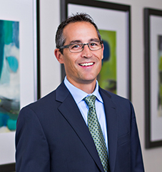

Name: David Bevins

David Bevins is a Shareholder with the Grand Rapids law firm of Rhoades McKee PC, where he has practiced for the last 20 years. David specializes in business/commercial matters, including representing financial institutions, resolving business disputes, and providing advice to businesses. In addition to helping banks with documenting commercial loans and assisting with their loan workout issues, including representation in bankruptcy court, David has also represented numerous receivers in courts throughout West Michigan. David appears in all state and federal courts litigating business and business-related matters.

