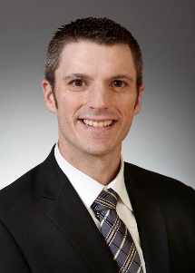
Name: Denny M. Briggs
Background: Career in lending industry of 15 years beginning with a local leasing company for 2.5 years. The balance of my lending career was spent at Chemical Bank specializing in listening to customer’s needs and formulating a creative approach to provide a tailored loan structure fitting the needs and wants of the customer.

Skills & expertise: Creative approach to providing lending solutions tailored to client’s needs in the following industries:
Commercial & Industrial – Manufacturing, Distribution etc.
Real Estate Development
Construction
SBA Loans

Education & Licensing- (include school and/or university):
Bachelors of Science Degree in Economics, Mathematics and Business Administration from Aquinas College.

Masters of Business Administration from Grand Valley State University.

Special awards, achievements:
2012 SBA Lender of the year – Economic Development Foundation

Community Involvement:
Chair of NextGen Committee – Turn Around Management Associates West Michigan
Deacon – Calvary Christian Reformed Church of Lowell
Formerly worked on Fundraising committee for Grand Rapids Opportunities for Women
Volunteer leader at Equest Center of Therapeutic Riding – Rockford, MI

New position responsibilities:

Taking Horizon Bank’s motto of providing ‘Exceptional Service; Sensible Advice’ and using it to compliment my approach to lending. The end goal is to provide simple solutions that are customized to fit client’s needs

