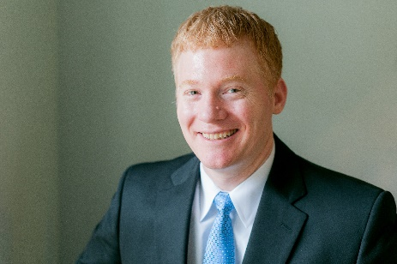

Name: Karl Norton

Karl R. Norton is a Vice President with over 15 years of banking experience with Comerica Bank. He has served Comerica’s Special Assets Group in West Michigan for the last 12 years, handling workout deals from the Middle Market, Small Business and Private Banking departments originated in Comerica’s Outstate region.

Karl is a Western Michigan University alum, graduating in 2000 with a Bachelor’s of Science degree in Finance and minor in Economics. Additionally, Karl serves on the board of the West Michigan TMA Chapter where he is the current Vice President. Karl is active in his community, serving on the Finance Committee for First United Methodist Church (FUMC) and previously as a FUMC coordinator for Family Promise GR. Karl resides with his wife, Angela, in Kentwood, MI.

